2014
COGSWELL/PELHAM
HALIFAX HARBOUR
CHAMPIONSHIP RACE
&
NORTHWEST ARM REGATTA

Sunday, September 28, 2014

Hosted by:

2014 HALIFAX HARBOUR CHAMPIONSHIP RACE AND NORTHWEST ARM REGATTA

RACE FORMAT

1) Halifax Harbour Championship Race (Cogswell Medal & Pelham Prize)

Singles will race the 4 km Northwest Arm course in a time trial format (See Map Appendix I). Rowers will assemble according to bow numbers at the Point Pleasant Park end of the Northwest Arm at 7:30 am. The starting order will follow the list of winners from 2013 (new entrants will be added to the end of the list). Each rower will be called through the start line in roughly 15-20 second intervals. Race results will be based on the time taken to complete the course.

2) Northwest Arm Regatta

The Northwest Arm Regatta will start at 8:30 am immediately after the Halifax Harbour Championship. Crew boats will race either a 1 km (Masters, Novice) or 2 km (Juniors, Open) time trial race course, with both races finishing in front of the St. Mary’s Boathouse (See Map Appendix II, III and IV). All boats for each flight must be at the designated start/pooling area prior to the start of the flight. Masters and Novice crews will race first followed by Juniors and Open. A time trial format will be used to determine the winner for each event. For all Junior and Open events, if there is only one crew in a race category, the event will still take place. There will be no medal awarded; however, the crew will be allowed to compete for a chance to race in the Duelling event.

The Regatta will conclude with a Duelling sprint race to determine the fastest boats on the Northwest Arm! The fastest times from the 2 km races will be used to determine the participants in this event. There will be four races in total; both male and female events for the fastest double and the fastest quad/four. The race course will be a 1 km sprint from the Dingle tower to the St. Mary’s Boathouse (See Map Appendix V). For each duelling race, two boats will line up at the start line for a standing start. These races will not be timed; the first boat to cross the finish line will win the race. Please note that the Regatta Chair and the Chief Umpire reserve the right to change the flight order if an individual happens to be in both races.

REGISTRATION

1. All entries MUST be in the hands of the Regatta Chair no later than midnight on
Friday September 19th, 2014. ONLY EMAIL ENTRIES WILL BE ACCEPTED. Please email entries to rowing@halifaxrowing.ca
2. The Registration form can be downloaded from the Halifax Rowing Club website. Registration forms for all clubs must be completed in full.
3. Athletes may register for a maximum of three events in the Northwest Arm Regatta. There is no limit to the number of events for Coxswains however races will not be delayed due to hot seating Coxswains.
4. RCA numbers (or equivalent for out of country participants) MUST be included on the registration form. No one who is not registered will be allowed to race.
5. The registration fees for the regatta are $25 per participant (including coxswains). Please note that all fees are due at the Safety Meeting on Saturday, September 27th.
6. Exact cash or cheques made payable to ‘Halifax Rowing Club” will be acceptable.

CATEGORY RESTRICTIONS

1. Novice (N): Must not have competed in any competitive regatta prior to Jan 1st, 2014.
2. Junior (JR): Must be less than 19 years of age this calendar year.
3. Open (O): Open to any age including Masters.
4. Masters (M): Must be 21 years of age or older this calendar year and registered as ‘competitive’ with RCA. Masters will be allowed to race in the Open category for this regatta.
5. Mix 4x/8+ (MIX): Crew must contain a minimum of 50% female rowers.
6. PARA: A PARA rower is a rower with a disability who meets the criteria set out in the RCA PARA Rowing classification rules.

FLIGHT SCHEDULE

Halifax Harbour Championship | Northwest Arm Regatta Flight 1 | Northwest Arm Regatta Flight 2 | Northwest Arm Regatta Flight 3 | Northwest Arm Regatta Flight 4 | Northwest Arm Regatta Flight 5
7:30 am Start | 8:30 am Start | 9:30 am Start | 10:30 am Start | 11:30 am Start | 12:30 am Start
1x (male)  1x (female) | JRW2x  JRM4x  NM2x  OM8+  OW4+  MMix4x | OW2x  OM4x  NW4+  OW8+  MM2x  MW4x | JRM2x  JRW4x  NM4+  MW8+  MM4x  NW2x | OW4x  OM2x  OM4+  MW2x  JRMix8+  PARA 2x | Two fastest 2x (male)  Two fastest 2x (female)  Two fastest 4x/+ (male)  Two fastest 4x/+ (female)

MISCELLANY

1. For the safety of the regatta there will be a check of boats to ensure that heel ties as well as bow balls are in place. Failure to meet the RCA safety restrictions for racing shells may result in disqualification.
2. There will be a safety meeting the night before the regatta, Saturday, September 27th, 2014, at 7:00pm at Halifax Rowing Club. All cox and bow seat competitors are encouraged to attend. The major rules of the regatta, the race schedule draw, and any other administrative details will be dealt with at the safety meeting. Registration fees must be paid in full at the safety meeting. Failure to do so will result in disqualification from the regatta.
3. There will be an Awards Ceremony and bbq lunch immediately following the final race. Food and refreshments are complimentary for regatta participants and volunteers; all others may purchase a food ticket for $5.

EVENTS SUMMARY

 | JRW | JRM | JRMix | OPW | OPM | MW | MM | MMix | NW | NM | PARA
1x
2x | X | X |  | X | X | X | X |  | X | X | X
4x | X | X |  | X | X | X | X | X
4+ |  |  |  | X | X |  |  |  | X | X
8+ |  |  | X | X | X | X

REGISTRATION INFORMATION

The registration form in Microsoft Excel format can be found on the Halifax Rowing Club website.

CONTACT INFORMATION
Laura Dowling or Linda Lee
Regatta Chairs
Halifax Rowing Club
rowing@halifaxrowing.ca
www.halifaxrowing.ca

RULES OF RACING

2014 HALIFAX HARBOUR CHAMPIONSHIP (COGSWELL MEDAL/PELHAM PRIZE) & NORTHWEST ARM REGATTA

The Northwest Arm is a narrow waterway with many obstacles, including moored and mobile boats. The Organizing Committee, officials, and regatta participants have no way of restricting traffic along the Arm, so please be aware there may be wake and other obstacles associated with the movements of sailboats and motorboats. Please be aware of the traffic flow pattern, warm-up areas, and other vessels present along the Northwest Arm. This will ensure a safe and successful racing experience.

- The Rowing Canada (RCA) Rules of Racing will apply for the duration of the Regatta.
- The start of all races (except the Duels in Flight 5) will be a flying start across the line. The start of event races will occur in 15-20 second intervals commencing at the flight start times (e.g. 7:30 am, 8:30 am, etc.). To avoid difficulty with the race schedule, please make sure your crews have adequate time to make it to the race start.
- In the event that a boat overtakes another boat, the Passer has the right of way to pass IF a safe pass can be accomplished. Please note: If a pass is attempted and there is not adequate room and time to perform the pass, the Passer is at risk of incurring interference penalties subject to the officials’ decision. The boat being overtaken must yield and give suitable room to the Passer if a safe pass can be accomplished. All scullers and crews: be alert to possible upcoming passing attempts and promptly yield when there is adequate room and time.
- The Duelling races in Flight 5 will follow standard sprint format with a standing start. The two boats in each duel are to line up next to each other; Lane 1 is on the Dingle side Lane 2 is closest to the HRC club. The umpire on shore at the Dingle Tower will align the two boats and start the race. There are no buoys marking the lanes for this race; the crews are expected to stay a safe distance away from each other during the race. An umpire boat will follow the races down to ensure there are no incidents.
- Any boat showing a blatant disregard for safety will be penalized and may be disqualified from the regatta.

Note:
- The Race Committee has the right to close the course and launch sites at any time during the regatta due to weather or safety concerns.
- Scullers and crews: do not cut across the race course at any time during the regatta. Please follow the traffic flow pattern outlined in the race package.
- Penalties are as such: 30 seconds for a passing violation.

HISTORY OF THE HALIFAX HARBOUR CHAMPIONSHIP AND THE COGSWELL MEDAL/PELHAM PRIZE

The history of Canadian Rowing is rich with events, one of the most significant of which is the race for the Cogswell Belt in Halifax, Nova Scotia. Many of the chroniclers of Canadian history consider the institution of the Cogswell Race the beginning of competitive rowing in Canada.

Dr. Charles Cogswell, physician and founder of the event, was born in Halifax on May 12, 1813 and died in England on January 2, 1892. He was a distinguished Haligonian who contributed much to the city. As well as practicing medicine, Dr. Cogswell became a City Alderman and is credited with the production of the City Crest. In 1887, he proposed a design for the Canadian flag that was to contain a beaver, three maple leaves and a jewelled crown. In 1938, on his behalf, the Mayor presented to the Halifax Cricket Club a flag that embodied in visible shape for the first time the province’s Coat of Arms. In 1858, Dr. Cogswell donated four hundred dollars and a belt for annual competition by single scullers in Halifax Harbour. The winner of three consecutive championships would retain the belt. In 1880, Warren Smith won and retained the belt after which the winner received a silver medal. A silver clasp was awarded for each subsequent win, but the winner of three consecutive races would receive a medal of Nova Scotia gold. The traditional presentation by Row Nova Scotia of a silver medal and a cheque based on the interest of the fund to the winner of the Halifax Harbour Championship persists to this day.

In 1883, the original bequest of $400 was increased to one thousand dollars to be invested at not less than five percent and the interest used to pay for the medals. If, for any reason, the annual interest from the principal should be less than $50, the City of Halifax agreed to make up the difference. The Mayor of Halifax and the Chairman of Public Accounts were appointed the trustees of the fund, now called the Halifax Harbour Championship Fund.

The first competition was held in 1858. For the next decade, the Belt was won and held first by George Lovett and then George Brown. Other notable Haligonians to have won the race include John Mann, Stewart Cogswell, Joe Reardon, Daniel P. Wallace, Bill Martin, Bob Sawler (past President of the Nova Scotia Rowing Association), and Bud Myra. 1984 Olympic Bronze Medallist, Bob Mills, won in 1983, 1984, 1986, and 2001. PanAm medallist and Olympian Todd Hallett won the Championship in 1996 and in 2003. More recent winners include Lawrence Nwaesei (1997), Dafydd Davies (2000), Pat Cody (2002), and Chris Williams (2004). In 2007, Tony Landry (MicMac Rowing Club) captured the Cogswell medal for the third consecutive year (2005, 2006 and 2007) and was ceremoniously awarded the Cogswell Belt, which is on display at the Maritime Museum of the Atlantic.

The Pelham Prize was established as an award for the top finisher of the opposite sex from the Cogswell Medal in the Halifax Harbour Championship. The prize is named after local rowing champion Henry Pelham (1908-1978). Henry was an avid sportsman and a man of many talents. Henry rowed with both the Jubilee Rowing Club and the MicMac Rowing Club and won numerous races with various crews. Fiercely competitive, Henry rowed with the Jubilee 4- crew of 1930, which placed second in the British Empire Games (precursor to the Commonwealth Games). In 1932, Henry was named to the Canadian Olympic 4-.

– Adapted from the Charles Cogswell Harbour Rowing Championship Trust Nova Scotia Rowing Association, with contributions from Linda Lee.

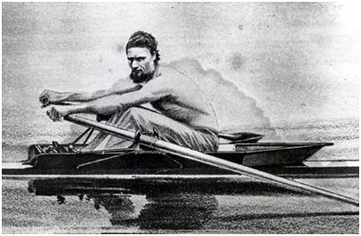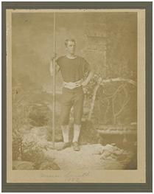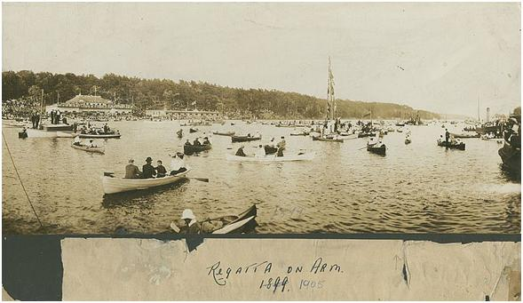
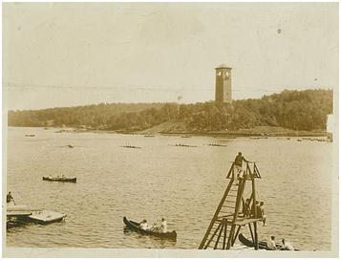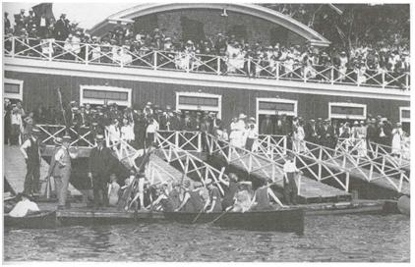

Selection of historical rowing images on the Northwest Arm¹

Top: George Brown (Left) and Warren Smith (Right), both 5 time winners of the Halifax Harbour Championship in the 1860’s and 70’s.
Middle: Regatta’s on the Northwest Arm were often viewed by tens of thousands of spectators both on land and in pleasure boats.
Bottom: Rowing crews racing past the Dingle Tower in 1912 (left). The Northwest Arm Rowing Club (right) in 1919 was one of many rowing clubs on the Arm.
¹ Images from the Nova Scotia Archives (Tom Connors: The Old Sport)
http://gov.ns.ca/nsarm/virtual/connors/
